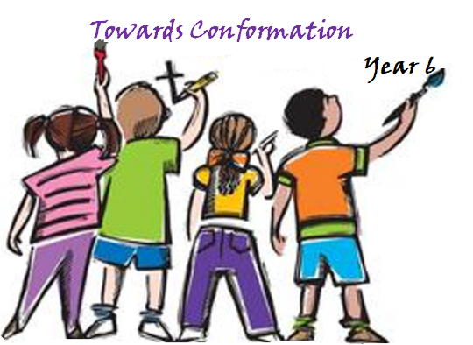

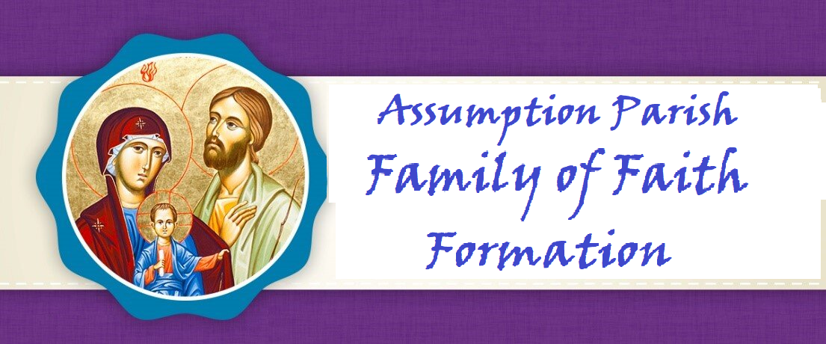

Mrs. Walsh

Year 6

2024-2025



**Dear Parents,**

*Along with our staff and Catechists, I want to welcome you to a new year as we journey together on the path to Heaven. I am grateful for the opportunity to walk this walk with you as your Father in faith.*

*The schedule of classes, events, meetings, trips, and spiritual gatherings are created all with the desire to offer you and your children many opportunities to deepen your love for Jesus. Loving Jesus is central to our faith. Nothing we teach or say will make sense to anyone without the foundation of love for Christ to come first. It is our hope that your entire family will take full advantage of these opportunities.*

*You are a gift to me, and I pray you are as joyful and excited as I am, with the start of our new year of formation. My gift to you is my prayer that God may bless you and your children. May He lead you to grow and deepen your faith as your family participates in all we offer you in His glorious and holy name.*

**Fr. Leo, Pastor**

**Dear Parents,**

*Welcome to the Church of the Assumption for the Blessed Virgin Mary Parish Faith Formation Program. It is our privilege to support you in your efforts to guide your child to a deeper and more meaningful Christian life following the doctrines and teachings of the Catholic Church. We are here to help all families of Assumption Parish with their faith formation needs and desire to engage the entire family on their spiritual journey. Please let us know what we can do to serve you.*

**Rose Strohmaier, Parish Catechetical Leader**

**PARISH MISSION STATEMENT**

The Mission of the Catholic Community of The Church of the Assumption is to be led by the Word of God, to proclaim God in our words and actions, and to bring all people to God like Mary our Blessed Mother.

**VISION OF OUR FAITH FORMATION PROGRAM**

The mission of the Office of Faith Formation is to proclaim the message of Jesus, to teach His truth, and to extend His love to all people. We hope to enable our parish community, beginning at birth and continuing through life, to discover, grow and mature in their faith experience, to deepen their relationship with Christ and His church, and to realize an excitement about the wonderful gifts received by participating in our faith.

**ROLE OF THE PARENTS**

**Family Participation**

Jesus is truly present with us at every Mass and that is why the significance of family Mass attendance cannot be minimized and is at the heart of our faith. It is our moment of intimacy with our Lord. This is His gift of love for us so we may grow in love for Him. Absolutely nothing about faith makes sense without loving Christ first. ***Faith Formation families are to attend either Saturday night or Sunday morning Mass.******Four times during the Faith Formation year, Father Leo meets with parents to discuss an article on the teaching of the faith which fulfills Diocesan guidelines which state:***

*“Parents need to understand that formal faith formation is a continuous developmental process that begins with First Communion preparation and continues through Confirmation. Attendance at parent formation sessions is required to help parents fully participate in their child’s preparation.”*

Pray the prayers in this handbook together with your child so the entire Family grows in faith as one. Your child will learn these prayers before entering Communion II.

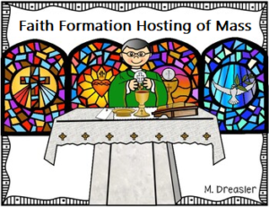• **MASS HOSTING**–Four times during the Faith Formation Year, each Catechist is responsible for hosting 10am Sunday Mass with his/her children. The Catechist plans for readers, servers, ushers, gifts, etc. Children are expected to dress for the solemn and Sacred celebration of the Holy Mass. They are expected to at least dress casually whereas their garments are clean, neat and modest (decent).

As a part of the Faith Formation Family, the children are to arrive to their assigned Mass at 9:45am, sit with their class and fully participate in the celebration of Mass. The dates are clearly stated on the calendar. Thank you for adjusting your schedule to be sure your child is at Mass on those four Sundays.

**PRAYERS YOUR CHILD KNOWS:**

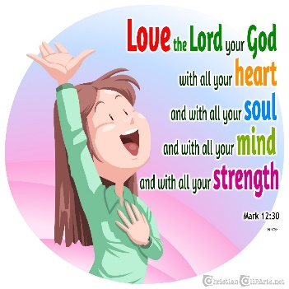**ACT OF CONTRITION**

My God, I am sorry for my sins with all my heart. In choosing to do wrong and failing to do good, I have sinned against you whom I should love above all things. I firmly intend, with your help, to do penance, to sin no more, and to avoid whatever leads me to sin. Our Savior Jesus Christ suffered and died for us. In his name, my God, have mercy.

**LORD’S PRAYER**

Our Father, who art in heaven, hallowed be thy name. Thy kingdom come, thy will be done, on earth, as it is in heaven. Give us this day, our daily bread and forgive us our trespasses as we forgive those who trespassed against us. Lead us not into temptation, but deliver us from evil. Amen

**HAIL MARY**

Hail Mary, full of grace, the Lord is with you. Blessed are you among women and blessed is the fruit of your womb, Jesus. Holy Mary, Mother of God, pray for us sinners, now, and at the hour of our death. Amen

**GLORY BE**

Glory be to the Father, and to the Son, and to the Holy Spirit. As it was in the beginning, is now, and ever shall be world without end. Amen

**PRAYER OF THANKS AFTER COMMUNION**

I thank You, O Lord my God, for You have made me worthy to be a partaker of Your Holy Things. I thank You, for You have permitted me, the unworthy, to receive your Son.

**GRACE BEFORE MEALS**

Bless us, O Lord! and these Thy gifts, which we are about to receive from Thy bounty, through Christ our Lord. Amen.

**ANGEL of GOD**

Angel of God, my guardian dear, to whom God’s love entrusts me here. Ever this day be at my side, to light and guard, to rule and guide. Amen

**THE CONFITEOR (I Confess)**

I confess to almighty God and to you, my brothers and sisters, that I have greatly sinned, in my thoughts and in my words, in what I have done, and in what I have failed to do; through my fault, through my fault, through my most grievous fault; therefore, I ask blessed Mary ever-Virgin, all the Angels and Saints, and you, my brothers and sisters, to pray for me to the Lord our God.

**Apostles Creed**

I believe in God,  
the Father almighty,  
Creator of heaven and earth,  
and in Jesus Christ, his only Son, our Lord,  
who was conceived by the Holy Spirit,  
born of the Virgin Mary,  
suffered under Pontius Pilate,  
was crucified, died and was buried;  
he descended into hell;  
on the third day he rose again from the dead; he ascended into heaven,

and is seated at the right hand of God the Father almighty;  
from there he will come to judge the living and the dead.

I believe in the Holy Spirit,  
the holy catholic Church,  
the communion of saints,  
the forgiveness of sins,  
the resurrection of the body,  
and life everlasting. Amen.

**INTRODUCED LAST YEAR**

(adapted from St. Mary’s of the Immaculate Conception, Portage, Wisconsin)

**Hail Holy Queen**

Hail, holy Queen, mother of mercy, our life, our sweetness, and our hope. To you we cry, poor banished children of Eve; to you we send up our sighs, mourning and weeping in this valley of tears. Turn, then, most gracious advocate, your eyes of mercy toward us; and after this, our exile, show unto us the blessed fruit of your womb, Jesus. O clement, O loving, O sweet Virgin Mary. Pray for us, O holy Mother of God. That we may be made worthy of the pro mises of Christ. Amen



**SCRIPTURE and DOCTRINE**

* The children will be familiar with Bible stories:
  + Jesus on Forgiveness (Matthew 18: 21-35)
  + Peter’s Declaration of Jesus (Matthew 16: 13-20)
  + The Story of the Rich Man and Lazarus (Luke 16:19-31, John 11:17-44)
  + The Story of the Woman at the Well (John 4:11-14)
  + The Story of Saul on the road to Damascus (Acts 9:1-30)
  + The Story of Job (Job 38:1-41)
  + The Story of Lazarus being raised from the dead (John 11:17-44)
  + The Story of the Transfiguration (Luke 9:28-36)
  + The Resurrection Stories (Matthew 28:1-20, Mark 16:1-18, Luke 24:1-35, John 20:11-29)
  + The Ascension (Mark 16:19-20, Luke 24:50-51, Acts 1:3-11)
  + God has Given Each of us Gifts to Share (Romans 12:1-8)
  + The Suffering Servant (Isaiah 50:4-9)
* Explain the meaning of the term “communion of saints”.
* Know that “faith” is our lifetime response to God who reveals himself to us (CCC: 26)
* Know that the Hebrew Scriptures (Old Testament) are honored as the Holy Word of God by both Jews and Christians
* Continue to use the Bible to look up scripture

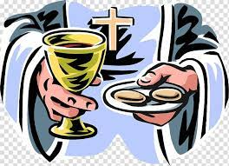

**LITURGY and EUCHARIST**

* The children will be able to explain the meaning of the consecration of the bread and wine (gestures, prayer and theology)
* The children will know the ways to prepare for Mass and make a plan to do it.
  + Read the readings prior to Mass
  + Fast, dress nicely, pray, be silent
  + Go to and participate at Mass regularly with family
  + Be aware of the upcoming readings and know where they are located in the Bible
  + Be aware of the content of the readings and how they are able to live those readings out in their daily lives
  + Participate in the Mass as servers, lectors, ushers, etc. four times a year with their class
  + Participate in the Sacraments of Reconciliation and Eucharist

**TEACHINGS:**

* The children will be familiar with the Beatitudes:
* Blessed are the poor in [spirit](https://www.catholic.org/encyclopedia/view.php?id=11004) : for theirs is the kingdom of heaven. ( Verse 3 )
* Blessed are the meek: for they shall posses the land. ( Verse 4 )
* Blessed are they who mourn: for they shall be comforted. ( Verse 5 )
* Blessed are they that hunger and thirst after [justice](https://www.catholic.org/encyclopedia/view.php?id=6550) : for they shall have their fill. ( Verse 6 )
* Blessed are the merciful: for they shall obtain mercy. ( Verse 7 )
* Blessed are the clean of heart: for they shall see God. ( Verse 8 )
* Blessed are the peacemakers: for they shall be called the [children](https://www.catholic.org/shopping/?category=28) of God. ( Verse 9 )
* Blessed are they that suffer [persecution](https://www.catholic.org/encyclopedia/view.php?id=9187) for justice' sake, for theirs is the kingdom of heaven. ( Verse 10 )
* The children will memorize the Corporal Works of Mercy:
  + to feed the hungry
  + to give drink to the thirsty
  + to clothe the naked
  + to give shelter to travelers
  + to visit the sick
  + to visit the imprisoned
  + to bury the dead
* The children will memorize the Spiritual Works :
* counsel the doubtful
* instruct the ignorant
* admonish sinners
* comfort the afflicted
* forgive offenses
* bear wrongs patiently
* pray for the living and the dead

**PRAYER and SPIRITUALITY**

In preparation to choose a saint for Confirmation:

* Identify a patron saint and be able to tell about that saints life and how the saint followed Jesus example
* Identify at least five saints, be able to share something about their lives and describe what they most admire about those saints
* Participate in praying the Litany of the Saints
* Be able to explain the purpose of both private (personal) prayer and communal prayer
* Understand the purpose of praying a “Morning Offering” and begin to develop this practice
* Be able to discuss the importance of being vigilant in prayer – especially in terms of overcoming difficulties
* Have a plan to set aside some time each day for prayer
* Regularly practice an examination of conscience

**TO BE PRAYED AT HOME**

**The Morning Offering**

O Jesus, I offer you all my prayers, works, and sufferings of this day for all the intentions of your most Sacred Heart. Amen.

**The Mini-Litany of Saints**

Lord have mercy,  
**Christ have mercy on us**.

Christ hear us,  
**Christ graciously hear us**.

God the Father,  
**have mercy on us.**

God the Son,  
**have mercy on us.**

God the Holy Spirit,  
**have mercy on us.**

Holy Trinity,  
**have mercy on us.**

Holy Mary, **pray for us.**  
St. Michael, **pray for us.**  
St. Gabriel, **pray for us.**  
St. Raphael, **pray for us.**  
All you holy angels and archangels, **pray for us.**

St. John the Baptist, **pray for us.**  
St. Joseph, **pray for us**.  
All you holy Patriarchs and prophets, **pray for us.**

St. Peter, **pray for us**.  
St. Paul, **pray for us.**  
St. Andrew, **pray for us.**  
St. James,**pray for us.**  
St. John, **pray for us.**  
St. Mary Magdalen, **pray for us.**  
All you holy apostles and evangelists, **pray for us**.  
All you holy martyrs,**pray for us.**

All you men and women, Saints of God, make intercession for us.  
**Be merciful, spare us, O Lord!**

Lord, be merciful,  
**graciously hear us, O Lord!**

From all evil, **O Lord, deliver us.**  
From all sin, **O Lord, deliver us.**  
From anger and hatred,  **O Lord, deliver us.**

Through your death and resurrection, **O Lord, deliver us.**

In the day of judgement,  
**O Lord, hear us.**

That you would forgive us and all those we love,  
**O Lord, hear us.**

That you would grant peace and unity to all,  
**O Lord, hear us.**

That you would give rest to those who have died,  
**O Lord, hear us.**

That you would lift up our minds to heavenly desires,  
**O Lord, hear us.**

Son of God,  
**O Lord, hear us.**

Lamb of God, who takes away the sins of the world,  
**Spare us, O Lord.**

Lamb of God, who takes away the sins of the world,  
**Graciously hear us, O Lord.**

Lamb of God, who takes away the sins of the world,  
**Have mercy on us.**

Say the Lord’s Prayer (Our Fathe

**Year 6 Calendar 2024-2025**

**Wednesdays:** 6:30-8:00PM

Rose Strohmaier, Parish Catechetical Leader—908-303-9692

**DROP OFF AND PICK UP—PARENTS MUST PARK CARS IN THE KNIGHTS’ PARKING LOT AND COME INTO THE CAFETERIA TO PICK UP CHILDREN**

**September**

**Sunday 22—Faith Formation Family Mass-10:00 AM**

Wednesday 25—Faith Formation Parents and children arrive at 6:30—Parent Meeting

**October**

Wednesday 2—Faith Formation**—Parents stay to meet with Mrs. Rose**

**Sunday 6—Year 6—10:00AM Mass—arrive 9:45AM dressed and prepared for hosting**

Wednesday 9—Faith Formation **Father Leo Parent Meeting**

Wednesday 16—Faith Formation

Wednesday 23—Faith Formation--**Oral Saint Reports Given by Confirmandi during Class Time**

**Monday 28—Norma Rothshadl from OSV—Training Catechist Only—No Children**

Wednesday 30— No Faith Formation

**November**

**Friday 1—All Saints Day—Holy Day—All Attend Mass**

Wednesday6—Faith Formation-- **Father Leo Parent Meeting**

Wednesday 13—Faith Formation—**Adoration Both Sessions**

**Sunday 17—Year 6—Hosts 10:00AM Mass—arrive 9:45AM dressed and prepared for hosting**

Wednesday 20—Faith Formation

Wednesday27— **No Faith Formation Happy Thanksgiving**



This Photo by Unknown Author is licensed under CC BY-NC-ND

**December**

Wednesday 4—Faith Formation **Reconciliation--Parents encouraged to attend with their child**

Wednesday 11—Faith Formation **Empower God’s Children—Part I Video in Cafeteria**

Wednesday 18—Faith Formation **Before Classes—6:00PM Tree Blessing and Carols with Hot Chocolate Tree**

Saturday 21—**4:15—Children’s Mass and Nativity (Nativity will take place before 5:30PM Mass)**

**Wednesday 25—Merry Christmas! All go to Mass**

**January**

**Wednesday 1—Mary, Mother of God—All Attend Mass**

Wednesday 8—No Faith Formation for Children—Catechist Night of Reflection

Wednesday 15—Faith Formation

**Sunday 19—Year 6—Hosts 10:00AM Mass—arrive 9:50AM dressed and prepared for hosting**

Wednesday 22—Faith Formation-- **Father Leo Parent Meeting**

Wednesday 29—Faith Formation- **Evaluations go Home—Adoration**

**February**

Wednesday 5—Faith Formation

Wednesday 12—Faith Formation

Wednesday 19— Faith Formation— **Father Leo Parent Meeting**

**Sunday 23— Year 6—arrive 9:45AM dressed and prepared for hosting; be sure to sign-in**

Wednesday 26—Faith Formation **Father** **Leo and Deacons will meet with Confirmation Candidates**

**March**

Wednesday 5—**Ash Wednesday** – No Faith Formation

Wednesday 12—Faith Formation **Empowering God’s Children Video Part II—Afterwards Mini Retreat Year 6**

Wednesday 19—Faith Formation

Wednesday 26—Faith Formation

**April**

Wednesday 2— **No Faith Formation for Children-Catechist Night of Reflection**

Wednesday 9—Faith Formation **Reconciliation Parents encouraged to attend with their child**

**Sunday 13—Palm Sunday**

Wednesday 16—Faith Formation

**Sunday 20—Easter**

**Wednesday 23—Easter Vacation**

Wednesday 30—Faith Formation

**May**

**Sunday 4—Family Mass with May Crowning–All Families Must Attend**

Wednesday 7—Faith Formation