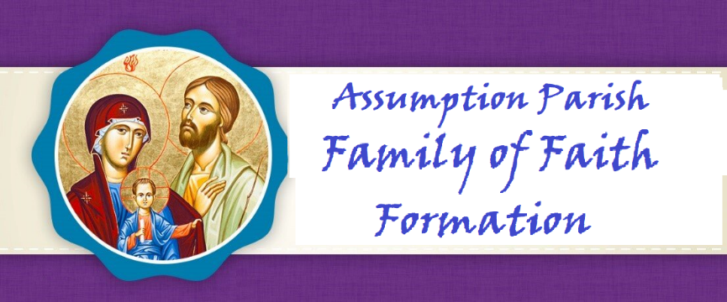

Ms. Principe

Year 4

2024-2025

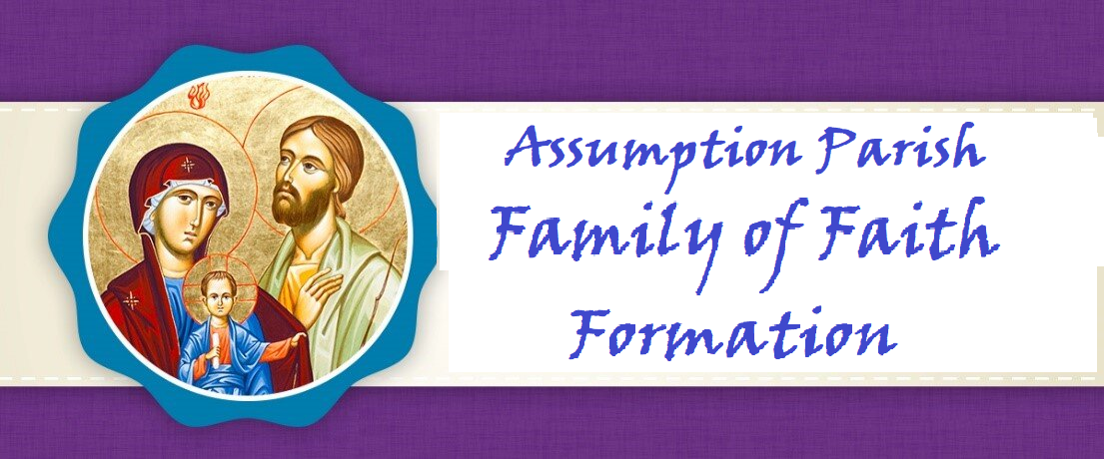

**Dear Parents,**

*Along with our staff and Catechists, I want to welcome you to a new year as we journey together on the path to Heaven. I am grateful for the opportunity to walk this walk with you as your Father in faith.*

*The schedule of classes, events, meetings, trips, and spiritual gatherings are created all with the desire to offer you and your children many opportunities to deepen your love for Jesus. Loving Jesus is central to our faith. Nothing we teach or say will make sense to anyone without the foundation of love for Christ to come first. It is our hope that your entire family will take full advantage of these opportunities.*

*You are a gift to me, and I pray you are as joyful and excited as I am, with the start of our new year of formation. My gift to you is my prayer that God may bless you and your children. May He lead you to grow and deepen your faith as your family participates in all we offer you in His glorious and holy name.*

**Fr. Leo, Pastor**

**Dear Parents,**

*Welcome to the Church of the Assumption for the Blessed Virgin Mary Parish Faith Formation Program. It is our privilege to support you in your efforts to guide your child to a deeper and more meaningful Christian life following the doctrines and teachings of the Catholic Church. We are here to help all families of Assumption Parish with their faith formation needs and desire to engage the entire family on their spiritual journey. Please let us know what we can do to serve you.*

**Rose Strohmaier**

**Parish Catechetical Leader**

## 

## PARISH MISSION STATEMENT

The Mission of the Catholic Community of The Church of the Assumption is to be led by the Word of God, to proclaim God in our words and actions, and to bring all people to God like Mary our Blessed Mother.

**VISION OF OUR FAITH FORMATION PROGRAM**

The mission of the Office of Faith Formation is to proclaim the message of Jesus, to teach His truth, and to extend His love to all people. We hope to enable our parish community, beginning at birth and continuing through life, to discover, grow and mature in their faith experience, to deepen their relationship with Christ and His church, and to realize an excitement about the wonderful gifts received by participating in our faith.

**ROLE OF THE PARENTS**

**Family Participation**

Jesus is truly present with us at every Mass and that is why the significance of family Mass attendance cannot be minimized and is at the heart of our faith. It is our moment of intimacy with our Lord. This is His gift of love for us so we may grow in love for Him. Absolutely nothing about faith makes sense without loving Christ first. ***Faith Formation families are to attend either Saturday night or Sunday morning Mass.******Four times during the Faith Formation year, Father Leo meets with parents to discuss an article on the teaching of the faith which fulfills Diocesan guidelines which state:***

*“Parents need to understand that formal faith formation is a continuous developmental process that begins with First Communion preparation and continues through Confirmation. Attendance at parent formation sessions is required to help parents fully participate in their child’s preparation.”*

Pray the prayers in this handbook together with your child so the entire Family grows in faith as one. Your child will learn these prayers before entering Communion II.

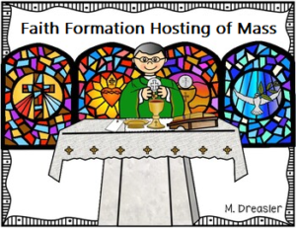• **MASS HOSTING**–Four times during the Faith Formation Year, each Catechist is responsible for hosting 10am Sunday Mass with his/her children. The Catechist plans for readers, servers, ushers, gifts, etc. Children are expected to dress for the solemn and Sacred celebration of the Holy Mass. They are expected to at least dress casually whereas their garments are clean, neat and modest (decent).

As a part of the Faith Formation Family, the children are to arrive to their assigned Mass at 9:45am, sit with their class and fully participate in the celebration of Mass. The dates are clearly stated on the calendar. Thank you for adjusting your schedule to be sure your child is at Mass on those four Sundays.

**PRAYERS YOUR CHILD KNOWS:**

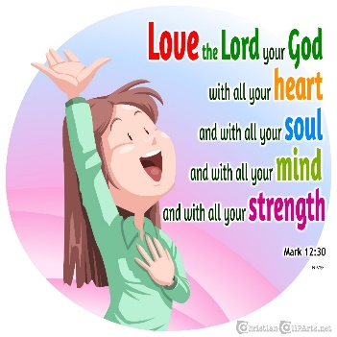**ACT OF CONTRITION**

My God, I am sorry for my sins with all my heart. In choosing to do wrong and failing to do good, I have sinned against you whom I should love above all things. I firmly intend, with your help, to do penance, to sin no more, and to avoid whatever leads me to sin. Our Savior Jesus Christ suffered and died for us. In his name, my God, have mercy.

**LORD’S PRAYER**

Our Father, who art in heaven, hallowed be thy name. Thy kingdom come, thy will be done, on earth, as it is in heaven. Give us this day, our daily bread and forgive us our trespasses as we forgive those who trespassed against us. Lead us not into temptation, but deliver us from evil. Amen

**HAIL MARY**

Hail Mary, full of grace, the Lord is with you. Blessed are you among women and blessed is the fruit of your womb, Jesus. Holy Mary, Mother of God, pray for us sinners, now, and at the hour of our death. Amen

**GLORY BE**

Glory be to the Father, and to the Son, and to the Holy Spirit. As it was in the beginning, is now, and ever shall be world without end. Amen

**PRAYER OF THANKS AFTER COMMUNION**

I thank You, O Lord my God, for You have made me worthy to be a partaker of Your Holy Things. I thank You, for You have permitted me, the unworthy, to receive your Son.

**GRACE BEFORE MEALS**

Bless us, O Lord! and these Thy gifts, which we are about to receive from Thy bounty, through Christ our Lord. Amen.

**ANGEL of GOD**

Angel of God, my guardian dear, to whom God’s love entrusts me here. Ever this day be at my side, to light and guard, to rule and guide. Amen

**INTRODUCED LAST YEAR AND CONTINUE TO PRAY:**

**THE CONFITEOR (I Confess)**

I confess to almighty God and to you, my brothers and sisters, that I have greatly sinned, in my thoughts and in my words, in what I have done, and in what I have failed to do; through my fault, through my fault, through my most grievous fault; therefore, I ask blessed Mary ever-Virgin, all the Angels and Saints, and you, my brothers and sisters, to pray for me to the Lord our God.

**Prayer Your Child Will Know Before Moving Onto Year 5:**

**(adapted from St. Mary of the Immaculate Conception, Portage, Wisconsin)**

**Apostles Creed**

I believe in God,  
the Father almighty,  
Creator of heaven and earth,  
and in Jesus Christ, his only Son, our Lord,  
who was conceived by the Holy Spirit,  
born of the Virgin Mary,  
suffered under Pontius Pilate,  
was crucified, died and was buried;  
he descended into hell;  
on the third day he rose again from the dead;  
he ascended into heaven,  
and is seated at the right hand of God the Father almighty;  
from there he will come to judge the living and the dead.

I believe in the Holy Spirit,  
the holy catholic Church,  
the communion of saints,  
the forgiveness of sins,  
the resurrection of the body,  
and life everlasting. Amen.



**SCRIPTURE**:

Your child will know the stories of the following Bible characters: Abraham, Sarah, Isaac, Jacob, and Joseph.

• Be able to retell the following Bible stories:

o The Story of David and Goliath (1 Samuel 17:1-54)

o The Story of Jonah and the Whale (Jonah 1:1-17)

o The Story of Jesus Walking on the Water (Matthew 14:22-33; Mark 6:45-52)

o The Story of Jesus and Zacchaeus (Luke 19:1-10)

o The Story of the Wedding at Cana (John 2:1-11)

o The Parable of the Good Samaritan (Luke 10:25-37) o The Story of Pentecost (Acts 2:1 42)

* Listen to/Have heard the following Bible Stories:

o The Story of Isaac, Jacob & Esau (Genesis 27:1-29)

o The Story of Joseph (Genesis 37:1-36)

o The Story of John the Baptist (Luke 1:5-25, 57-66)

o The Story of the Baptism of Jesus (Matthew 3:13-17, Mark 1:1-8)

o Annunciation and Mary’s “yes” to God (Luke 1:26-38)

o Jesus’ Entry into Jerusalem (Matthew 21:1-11)

o The Parable of the Last Judgment (Matthew 23: 31-46)

o Treat Others with Kindness (Ephesians 4:1-6)

**LITURGY and EUCHARIST**

* Your child will have a tour the liturgical worship space and be able to identify objects by name, location and purpose:
  + Sanctuary
  + Sacristy
  + Altar/Altar Cloth
  + Tabernacle/ Sanctuary Lamp
  + Altar Candles/ Votive Candles
  + Crucifix
  + Baptismal font /Holy Water
  + Stained Glass o Sacramentary
  + Lectionary and Roman Missal
  + Ambo/Lectern
  + Paschal Candle
  + Hymnal o Statues
  + Stations of the Cross
  + Vestments o Chalice and Ciborium
  + Hosts and wine
  + Oils

**HOSTING and PARICIPATING IN THE MASS**

Your family will attend and participate during Mass regularly. Your child will host Mass four times during the year with his/her class. They will:

* + Know that the First Reading comes from the Old Testament
  + Know that the Second Reading comes from the Epistles of the New Testament
  + Be able to share something they remember about the Gospel reading
  + Be able to share something they remember about Fr. Leo’s homily
  + Participate in the Sacraments of Reconciliation and Eucharist

**PRAYER and SPIRITUALITY**

* + Be aware there are Five Mysteries of the Rosary—Joyful, Sorrowful, Luminous, Glorious
  + Had experience with praying one decade of the rosary
  + Participate in the Stations of the Cross during Lent
  + Know that prayer begins with thanksgiving followed petition and contrition
  + Set a plan to develop an independent prayer life
  + Know what a saint is and how saints followed Jesus example

(Be able to name a few saints)

**Year 4 Calendar 2024-2025**

**Wednesdays:** 4:15PM-5:30PM

**DROP OFF AND PICK UP—PARENTS MUST PARK CARS IN THE KNIGHTS’ PARKING LOT AND COME**

**INTO THE CAFETERIA TO PICK UP CHILDREN.**

**September**

**Sunday** 22**—Faith Formation Family Mass-10:00 AM**

Wednesday 25—Faith Formation

**October**

Wednesday 2—Faith Formation**—Parents stay to meet with Mrs. Rose**

Wednesday 9—Faith Formation----**Father Leo—Parent Meeting**

**Sunday 13—Year 4 Hosts 10:00AM Mass—arrive no later than 9:45AM**

Wednesday 16—Faith Formation—Holyween During Class—Parents Invited

Wednesday 23—Faith Formation— **Empowering God’s Children Video**

**Monday 28—Norma Rothshadl from OSV—Training—Catechists Only—NO Children**

Wednesday 30—Faith Formation

**November**

**Friday 1—All Saints Day—Holy Day—All Attend Mass**

Wednesday6—Faith Formation--**Father Leo Parent Session**

Wednesday 13—Faith Formation—**Adoration**

Wednesday 20—Faith Formation

**Sunday** **24— Year 4 Hosts 10:00AM—arrive no later than 9:45AM**

Wednesday27**— No Faith Formation Happy Thanksgiving!**



This Photo by Unknown Author is licensed under CC BY-NC-ND

**December**

Wednesday **4—Reconciliation—Parents encouraged to attend with their child**

Wednesday 11—Faith Formation

**Sunday** 15—**Year 4 Hosts 10:00AM Mass—arrive no later than 9:45AM**

Wednesday 18—Faith Formation **– After Classes—6:00PM Tree Blessing and Carols with Hot Chocolate**

Saturday 21—**4:15—Children’s Mass and Nativity (Nativity will take place before 5:30PM Mass)**

**Wednesday 25—Merry Christmas! All go to Mass 😊**

**January**

**Wednesday 1—Mary, Mother of God—All families attend Mass**

**Wednesday** 8—**No Faith Formation for Children-Catechist Night of Reflection**

Wednesday 15—Faith Formation

Wednesday 22—Faith Formation--**Father Leo-- Parent Session**

Wednesday 29—Faith Formation- **Evaluations go Home—Adoration**

**February**

Wednesday 5—Faith Formation

Wednesday 12—Faith Formation

Wednesday 19— Faith Formation—**Father Leo-- Parent Session**

**Wednesday** 26—Faith Formation

**March**

**Sunday 2—Year 4 Hosts 10:00AM Mass—arrive no later than 9:45AM**

Wednesday 5—**Ash Wednesday** – No Faith Formation

Wednesday 12—Faith Formation **Empowering God’s Children Video**

Wednesday 19—Faith Formation

Wednesday 26—Faith Formation

**April**

Wednesday 2— NO Faith Formation for Children—Parents Night of Reflection

Wednesday 9—Faith Formation **Sacrament of Reconciliation—Parents invited**

**Sunday 13—Palm Sunday**

Wednesday 16—Faith Formation

**Sunday 20—Easter**

**Wednesday 23—Easter Vacation**

Wednesday 30—Faith Formation

**May**

**Sunday 4—Family Mass with May Crowning–All Families Must Attend**

Wednesday 7—Faith Formation