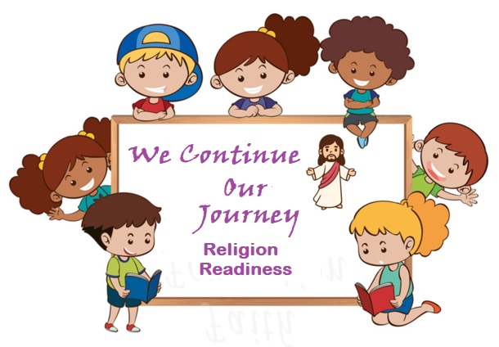

Faith Formation

Ms. Oseguera-Youth

Ms. Penafiel-Teen

2024-2025

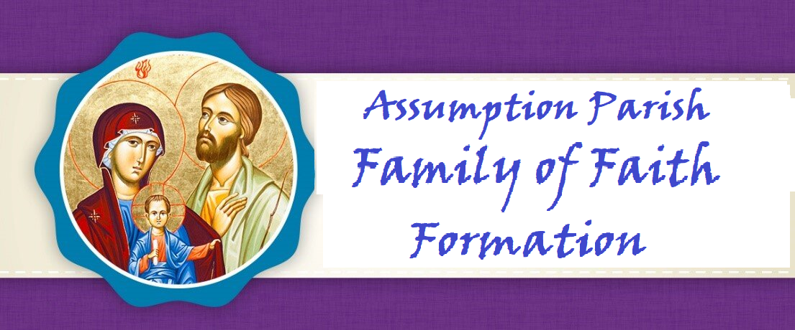

**Dear Parents,**

*Along with our staff and Catechists, I want to welcome you to a new year as we journey together on the path to Heaven. I am grateful for the opportunity to walk this walk with you as your Father in faith.*

*The schedule of classes, events, meetings, trips, and spiritual gatherings are created all with the desire to offer you and your children many opportunities to deepen your love for Jesus. Loving Jesus is central to our faith. Nothing we teach or say will make sense to anyone without the foundation of love for Christ to come first. It is our hope that your entire family will take full advantage of these opportunities.*

*You are a gift to me, and I pray you are as joyful and excited as I am, with the start of our new year of formation. My gift to you is my prayer that God may bless you and your children. May He lead you to grow and deepen your faith as your family participates in all we offer you in His glorious and holy name.*

**Fr. Leo, Pastor**

**Dear Parents,**

*Welcome to the Church of the Assumption for the Blessed Virgin Mary Parish Faith Formation Program. It is our privilege to support you in your efforts to guide your child to a deeper and more meaningful Christian life following the doctrines and teachings of the Catholic Church. We are here to help all families of Assumption Parish with their faith formation needs and desire to engage the entire family on their spiritual journey. Please let us know what we can do to serve you.*

**Rose Strohmaier**

**Parish Catechetical Leader**

## PARISH MISSION STATEMENT

The Mission of the Catholic Community of The Church of the Assumption is to be led by the Word of God, to proclaim God in our words and actions, and to bring all people to God like Mary our Blessed Mother.

**VISION OF OUR FAITH FORMATION PROGRAM**

The mission of the Office of Faith Formation is to proclaim the message of Jesus, to teach His truth, and to extend His love to all people. We hope to enable our parish community, beginning at birth and continuing through life, to discover, grow and mature in their faith experience, to deepen their relationship with Christ and His church, and to realize an excitement about the wonderful gifts received by participating in our faith.

**ROLE OF THE PARENTS**

**Family Participation**

Jesus is truly present with us at every Mass and that is why the significance of family Mass attendance cannot be minimized and is at the heart of our faith. It is our moment of intimacy with our Lord. This is His gift of love for us so we may grow in love for Him. Absolutely nothing about faith makes sense without loving Christ first. ***Faith Formation families are to attend either Saturday night or Sunday morning Mass.******Four times during the Faith Formation year, Father Leo meets with parents to discuss an article on the teaching of the faith which fulfills Diocesan guidelines which state:***

*“Parents need to understand that formal faith formation is a continuous developmental process that begins with First Communion preparation and continues through Confirmation. Attendance at parent formation sessions is required to help parents fully participate in their child’s preparation.”*

Pray the prayers in this handbook together with your child so the entire Family grows in faith as one. Your child will learn these prayers before entering Communion II.

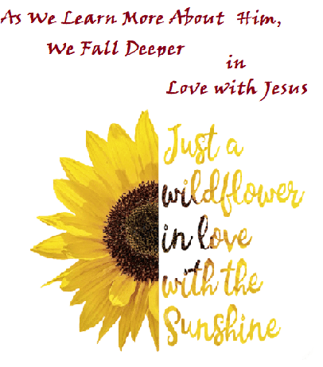

**To Know Him is to Love Him**

What a wonderful opportunity for the family to continue growing in faith as each member learns more about who Jesus is! Time is of a premium for all families—why not discuss some of these each night at dinnertime… instead of watching TV…before bedtime? Make a habit of spending time with your child at some point during the day and you will NEVER regret it. Christ has a way of changing hearts and bonding families. All we need do is participate in His grace.

*By this time, your child knows the Hail Mary, Our Father, Glory Be, Grace before Meals, Angel Prayer, Act of Contrition, Prayer of Thanks After Communion*

**Scripture:**

• There are two books in the Bible—Old Testament and which are in the New Testament

* New Testament tells us about the Life of Jesus who shows how to love God and others

• The Old Testament writings are about God’s relationship with His

chosen people, the Hebrews

• There is truth, beauty and goodness in scripture which is read every Sunday

• The Greatest Commandment is to love God with our whole heart and mind and love our neighbor as ourselves.

* Have heard the Bible stories—Adam and Eve, Noah, David and Goliath, Samson, Abraham and Isaac, Jacob and Esau, Joseph



• **CLASS MASS**–Four times during the Faith Formation Year, the children will attend 10:00AM Sunday Mass with their Catechist. In class the children will learn Mass etiquette and prayerful posture to exercise during Mass. Children are to arrive no later than 9:45AM and will sit in the reserved pews on the front right side (facing the altar) of the church. They will participate in the Mass fully and follow the guidelines and direction of their Catechists

**FAITH KNOWLEDGE TO REVIEW IN CLASS AND AT HOME**

**The Ten Commandments**

1. I am the Lord your God: you shall not have strange gods before me.

2. You shall not take the name of the Lord your God in vain.

3. Remember to keep holy the Lord’s Day.

4. Honor your father and your mother.

5. You shall not kill.

6. You shall not commit adultery.

7. You shall not steal.

8. You shall not bear false witness against your neighbor.

9. You shall not covet your neighbor’s wife.

10. You shall not covet your neighbor’s goods.

God reveals Himself to us through Scripture, the Church, creation, families, people, life events

• Jesus is, at the same, true God and true Man

• God is Trinity–God is Creator, Jesus is Healer and Teacher, the Holy Spirit is Comforter

• The “Three Last Things” are Heaven, Hell and Purgatory

* Sinful acts interfere with our relationship with God, others, creation and self

• There are seven sacraments—Baptism, Confirmation and Eucharist are sacraments of initiation; Reconciliation and Anointing of the Sick are sacraments of healing; Eucharist is the Body and Blood of Jesus

• There are 5 Liturgical seasons of the Church year—Advent, Christmas, Lent, Easter, Pentecost, and Ordinary Time

* There are 5 Mysteries in the Rosary—Joyful, Sorrowful, Luminous and Glorious

**Your child will receive assessments during the time we are together so we are able to know what (s)he needs more support in so as to be prepared for Year 4.**

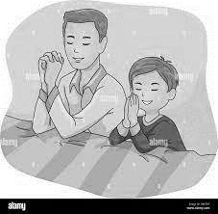

**PRAYERS YOUR CHILD KNOWS:**

**ACT OF CONTRITION**

My God, I am sorry for my sins with all my heart. In choosing to do wrong and failing to do good, I have sinned against you whom I should love above all things. I firmly intend, with your help, to do penance, to sin no more, and to avoid whatever leads me to sin. Our Savior Jesus Christ suffered and died for us. In his name, my God, have mercy.

**LORD’S PRAYER**

Our Father, who art in heaven, hallowed be thy name. Thy kingdom come, thy will be done, on earth, as it is in heaven. Give us this day, our daily bread and forgive us our trespasses as we forgive those who trespassed against us. Lead us not into temptation, but deliver us from evil. Amen

**HAIL MARY**

Hail Mary, full of grace, the Lord is with you. Blessed are you among women and blessed is the fruit of your womb, Jesus. Holy Mary, Mother of God, pray for us sinners, now, and at the hour of our death. Amen

**GLORY BE**

Glory be to the Father, and to the Son, and to the Holy Spirit. As it was in the beginning, is now, and ever shall be world without end. Amen

**PRAYER OF THANKS AFTER COMMUNION**

I thank You, O Lord my God, for You have made me worthy to be a partaker of Your Holy Things. I thank You, for You have permitted me, the unworthy, to receive your Son.

**GRACE BEFORE MEALS**

Bless us, O Lord! and these Thy gifts, which we are about to receive from Thy bounty, through Christ our Lord. Amen.

**ANGEL of GOD**

Angel of God, my guardian dear, to whom God’s love entrusts me here. Ever this day be at my side, to light and guard, to rule and guide. Amen

**The children will know this prayer before leaving Religious Readiness:**

**The Confiteor (I Confess)**

I confess to almighty God and to you, my brothers and sisters, that I have greatly sinned, in my thoughts and in my words, in what I have done, and in what I have failed to do;  
through my fault, through my fault, through my most grievous fault; therefore, I ask blessed Mary ever-Virgin, all the Angels and Saints, and you, my brothers and sisters, to pray for me to the Lord our God.

**Your Child will be Familiar with The Apostles Creed:**

**Apostles Creed**

I believe in God,  
the Father almighty,  
Creator of heaven and earth,  
and in Jesus Christ, his only Son, our Lord,  
who was conceived by the Holy Spirit,  
born of the Virgin Mary,  
suffered under Pontius Pilate,  
was crucified, died and was buried;  
he descended into hell;  
on the third day he rose again from the dead;  
he ascended into heaven,  
and is seated at the right hand of God the Father almighty;  
from there he will come to judge the living and the dead.

I believe in the Holy Spirit,  
the holy catholic Church,  
the communion of saints,  
the forgiveness of sins,  
the resurrection of the body,  
and life everlasting.

Amen.



**Religion Readiness Youth and Teen Calendar 2024-2025**

**Wednesdays**: 4:15-5:30—Youth---6:30-8:00PM--Teen

Rose Strohmaier, Parish Catechetical Leader—908-303-9692

**DROP OFF AND PICK UP—PARENTS MUST PARK CARS IN THE KNIGHTS’ PARKING LOT AND COME INTO THE CAFETERIA TO PICK UP CHILDREN**

**September**

**Wednesday 11—6:00PM Meet with Rose Religion Readiness I & II**

**Sunday** 22**—Faith Formation Family Mass-Catechists Host**

Wednesday 25—Faith Formation 4:15PM & 6:30PM

**October**

Wednesday 2—Faith Formation

Wednesday 9—Faith Formation--**Father Leo** **Meets with Parents**

Wednesday 16—Faith Formation—Holyween-Youth—1st Session Only 4:15-5:30

Wednesday 23—Faith Formation—Confirmandi Presents Saint Reports Second Session Only 6:30-8:00PM

**Monday 28—Norma Rothshadl from OSV—Training NO Children—Catechists Only**

Wednesday 30— Faith Formation

**November**

**Friday 1—All Saints Day—Holy Day—All Attend Mass**

Wednesday6—Faith Formation--**Father Leo Meets with Parents**

**Sunday 10**—**Religion Readiness Class Mass—Arrive to church by 9:45 dressed properly for Mass**

Wednesday 13—Faith Formation—**Adoration during Class**

Wednesday 20—Faith Formation

Wednesday27— **No Faith Formation Happy Thanksgiving**



This Photo by Unknown Author is licensed under CC BY-NC-ND

**December**

**Sunday 1**—**Religion Readiness Class Mass—Arrive to church by 9:45 dressed properly for Mass**

Wednesday 4—Faith Formation Reconciliation during class-Parents are encouraged to attend

Wednesday 11—Faith Formation

Wednesday 18—Faith Formation—**6:00PM Tree Blessing and Carols with Hot Chocolate and Cookies 6:00**

Saturday 21—**4:15—Children’s Mass and Nativity (Nativity will take place before 5:30PM Mass)**

**Wednesday** 25—**Merry Christmas! ☺**

**January**

**Wednesday 1—Mary, Mother of God—All Families Attend Mass**

**Wednesday** 8—**No Faith Formation for Children-Catechist Night of Reflection**

Wednesday 15—Faith Formation

Wednesday 22—Faith Formation—**Father Leo Meets with Parents**

Wednesday 29—Faith Formation- **Evaluations—Adoration during Class Time**

**February**

**Sunday 2—Religion Readiness Class Mass—Arrive to church by 9:45 dressed properly for Mass**

Wednesday 5—Faith Formation

Wednesday 12—Faith Formation

Wednesday 19— Faith Formation—**Father Leo Meets with Parents**

Wednesday 26—Faith Formation

**March**

Wednesday 5— **Ash Wednesday** – No Faith Formation

Wednesday 12—Faith Formation—**Empowering God’s Children—Part II Both Sessions during Class**

Wednesday 19—Faith Formation

**Sunday 23—Religion Readiness Class Mass—Arrive to church by 9:45 dressed properly for Mass**

Wednesday 26— Faith Formation

**April**

Wednesday 2— **No Faith Formation for Children-Catechist Night of Reflection**

Wednesday 9—Faith FormationReconciliation—Parents are encouraged to receive

Wednesday 16—Faith Formation

**Wednesday 23—Easter Vacation**

Wednesday 30—Faith Formation

**May**

**Sunday 4—May Crowning and Closing Mass—All Families Must Attend-Catechists Host**

Wednesday 7—Faith Formation