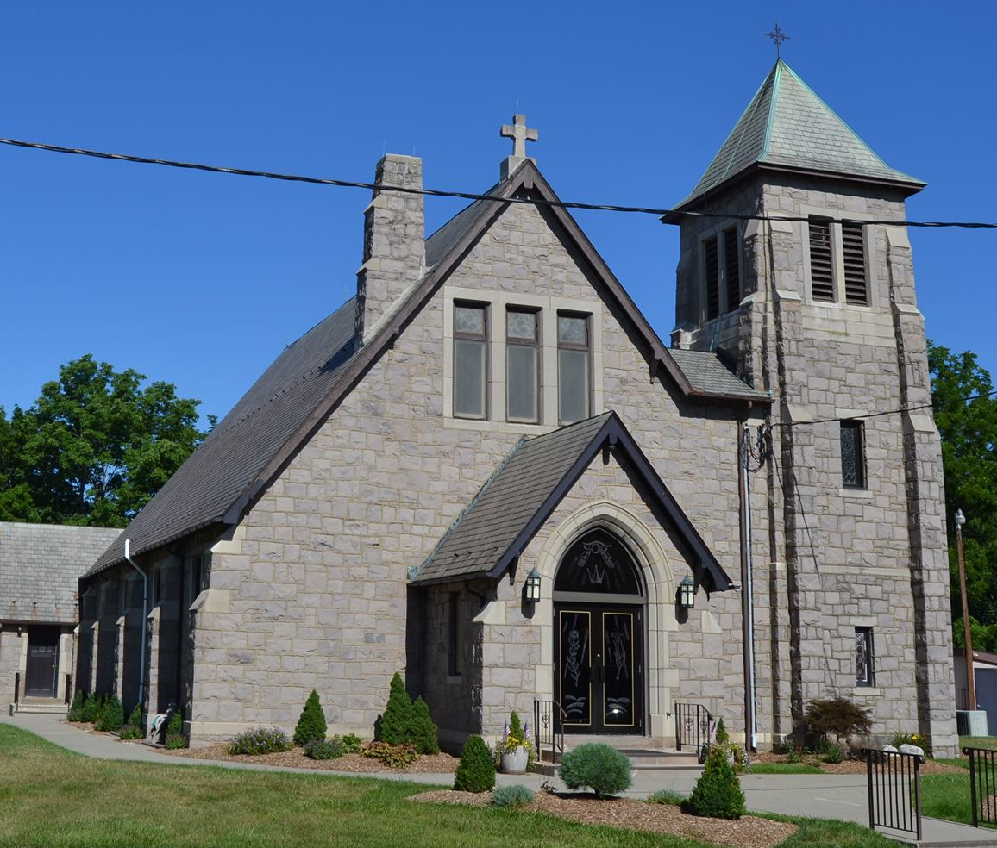
Church of the Assumption of the Blessed Virgin Mary
302 High Street, Hackettstown, NJ 07840
(908)852-3320 fax: (908)852-2361
E-mail: secretary@assumptionbvmnj.org
Website: www.assumptionbvmnj.org

