**Confirmation II Calendar 2024-2025**

**Wednesdays:** 6:30-8:00PM

Rose Strohmaier, Parish Catechetical Leader—908-303-9692

**DROP OFF AND PICK UP—PARENTS MUST PARK CARS IN THE KNIGHTS’ PARKING LOT AND COME INTO THE CAFETERIA TO PICK UP CHILDREN**

**August**

**Wednesday 21—7PM Meet with Mrs. Rose in the auditorium**

**September**

**Sunday 22—Faith Formation Family Mass-10:00 AM AND Catechists Host**

Wednesday 25—Faith Formation

**Sunday 29—Confirmation II Hosts 10:00AM Mass—arrive 9:45AM**

**October**

Wednesday 2—Faith Formation

Wednesday 9—Faith Formation--**Father Leo-- Parent Session**

Wednesday 16—Faith Formation

Wednesday 23—Faith Formation—**Presentation of** **Oral Saint Reports Given by Confirmandi – Parents Invited**

**Sunday 27—Confirmation II Hosts 10:00AM Mass—arrive 9:45AM**

**Monday 28—Norma Rothshadl from OSV—Training Catechists Only—No Children**

Wednesday 30—Faith Formation

**November**

**Friday 1—All Saints Day—Holy Day—All Attend Mass**

Wednesday6—Faith Formation--**Father Leo Parent Meeting**

Wednesday 13—Faith Formation—**Adoration**

Wednesday 20—Faith Formation—**Part 1 Retreat during Classtime**

Wednesday27— **No Faith Formation Happy Thanksgiving**

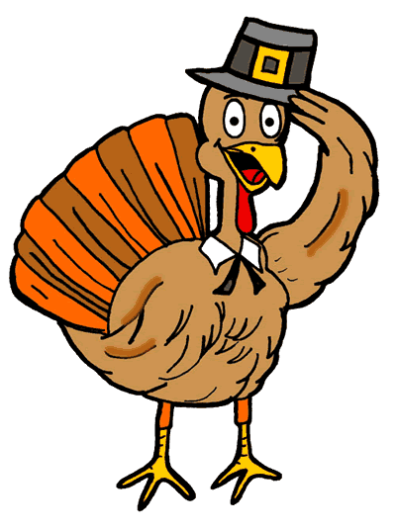

This Photo by Unknown Author is licensed under CC BY-NC-ND

**December**

Wednesday 4—Faith Formation **Reconciliation Parents encouraged to attend with their child**

**Sunday 8— Confirmation II—Hosts 10:00AM Mass—arrive 9:45AM dressed and prepared for hosting**

**Wednesday 11—Faith Formation Empowering God’s Children Video Part 1**

Wednesday 18—Faith Formation **– Before Class-6:00PM Tree Blessing with Hot Chocolate and Cookies**

Saturday 21—**4:15—Children’s Mass and Nativity (Nativity will take place before 5:30PM Mass)**

**Wednesday 25—Merry Christmas! All go to Mass**

**January**

**Wednesday 1—Mary, Mother of God—All Attend Mass**

**Wednesday** 8—**No Faith Formation for Children-Catechist Night of Reflection**

Wednesday 15—Faith Formation

Wednesday 22—Faith Formation--**Father Leo-- Parent Session**

Wednesday 29—Faith Formation- **Evaluations go Home—Adoration— SERVICE PROJECT RESPONSE DUE**

**February**

**Sunday 2—6:00-8:00PM Retreat—Part 2—Confirmation II Meet in the Auditorium with Sponsors**

Wednesday 5—Faith Formation

Wednesday 12—Faith Formation

Wednesday 19— Faith Formation—**Father Leo—Parent Meeting**

Wednesday 26—Faith Formation **Father** **Leo and Deacons will meet with Confirmation Candidates—**

**March**

Wednesday 5— **Ash Wednesday** – No Faith Formation

**Wednesday 12—Faith Formation** **Empowering God’s Children Video Part 2**

**Saturday 15—Confirmandi II Retreat with Confirmandi Sponsors 1:00PM-6:30PM**

Wednesday 19—Faith Formation—**6:30-8:00-Confirmation II Parent Meeting with Father Leo**

**ALTAR SERVING RESPONSE DUE**

**Sunday 23—Confirmation II Hosts 10:00AM Mass—arrive no later than 9:45AM**

Wednesday 26— Faith Formation **ADORATION RESPONSE DUE**

**April**

Wednesday 2—**No Faith Formation for Children-Catechist Night of Reflection**

Wednesday 9—Faith Formation **Reconciliation -- Parents encouraged to attend with their child**

**Sunday 13—Palm Sunday**

Wednesday 16—Faith Formation

**Sunday 20—Easter**

**Wednesday 23—Easter Vacation**

Wednesday 30—Faith Formation--Evaluations go home

**May**

**Sunday 4—May Crowning and Closing & Mass**

Wednesday 7—Faith Formation

* Confirmation Practice will be held at St. Peter and Paul Parish in Great Meadows TBD
* Confirmandi will wear dress clothes for Confirmation
* Confirmation Date to be Determined by Bishop Checchio

and will be held at Sts. Peter and Paul Parish, Great Meadows