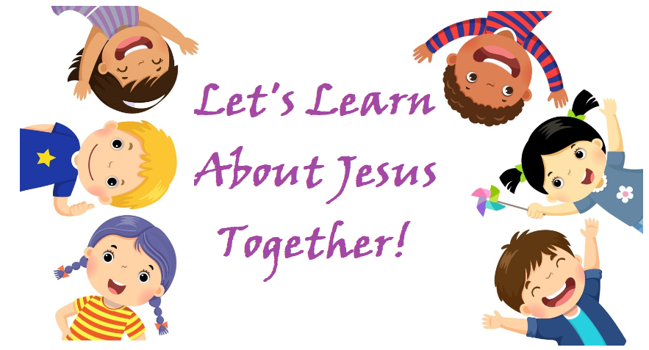

Mrs. Leguizamon

Communion II

2024-2025

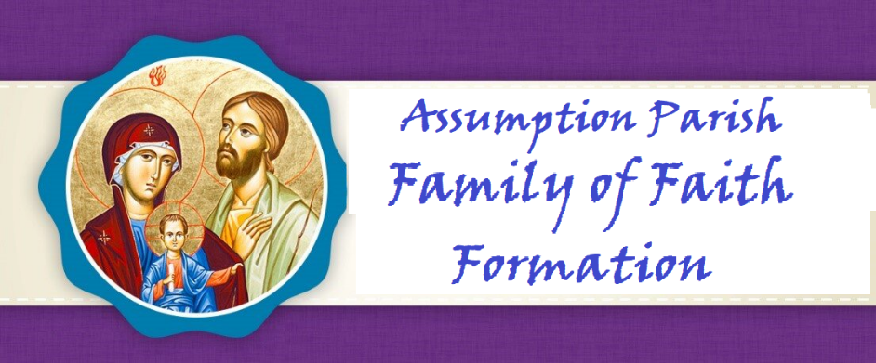

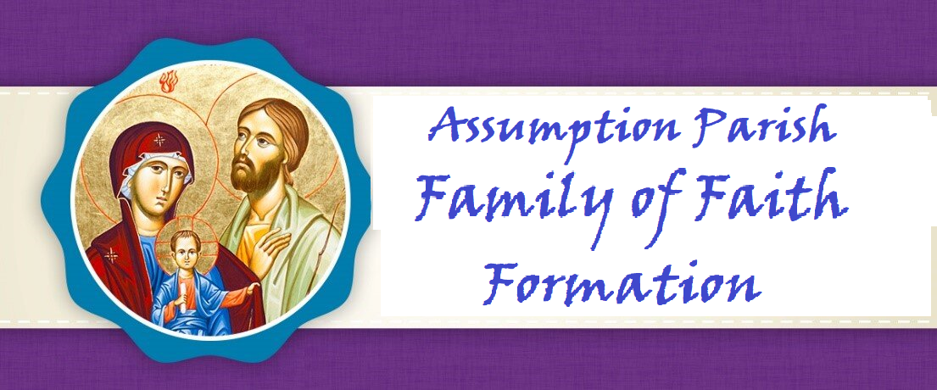

**Dear Parents,**

*Along with our staff and Catechists, I want to welcome you to a new year as we journey together on the path to Heaven. I am grateful for the opportunity to walk this walk with you as your Father in faith.*

*The schedule of classes, events, meetings, trips, and spiritual gatherings are created all with the desire to offer you and your children many opportunities to deepen your love for Jesus. Loving Jesus is central to our faith. Nothing we teach or say will make sense to anyone without the foundation of love for Christ to come first. It is our hope that your entire family will take full advantage of these opportunities.*

*You are a gift to me, and I pray you are as joyful and excited as I am, with the start of our new year of formation. My gift to you is my prayer that God may bless you and your children. May He lead you to grow and deepen your faith as your family participates in all we offer you in His glorious and holy name.*

**Fr. Leo, Pastor**

**Dear Parents,**

*Welcome to the Church of the Assumption for the Blessed Virgin Mary Parish Faith Formation Program. It is our privilege to support you in your efforts to guide your child to a deeper and more meaningful Christian life following the doctrines and teachings of the Catholic Church. We are here to help all families of Assumption Parish with their faith formation needs and desire to engage the entire family on their spiritual journey. Please let us know what we can do to serve you.*

**Rose Strohmaier**

**Parish Catechetical Leader**

## PARISH MISSION STATEMENT

The Mission of the Catholic Community of The Church of the Assumption is to be led by the Word of God, to proclaim God in our words and actions, and to bring all people to God like Mary our Blessed Mother.

**VISION OF OUR FAITH FORMATION PROGRAM**

The mission of the Office of Faith Formation is to proclaim the message of Jesus, to teach His truth, and to extend His love to all people. We hope to enable our parish community, beginning at birth and continuing through life, to discover, grow and mature in their faith experience, to deepen their relationship with Christ and His church, and to realize an excitement about the wonderful gifts received by participating in our faith.

**ROLE OF THE PARENTS**

**Family Participation**

Jesus is truly present with us at every Mass and that is why the significance of family Mass attendance cannot be minimized and is at the heart of our faith. It is our moment of intimacy with our Lord. This is His gift of love for us so we may grow in love for Him. Absolutely nothing about faith makes sense without loving Christ first. ***Faith Formation families are to attend either Saturday night or Sunday morning Mass.******Four times during the Faith Formation year, Father Leo meets with parents to discuss an article on the teaching of the faith which fulfills Diocesan guidelines which state:***

*“Parents need to understand that formal faith formation is a continuous developmental process that begins with First Communion preparation and continues through Confirmation. Attendance at parent formation sessions is required to help parents fully participate in their child’s preparation.”*

Pray the prayers in this handbook together with your child so the entire Family grows in faith as one. Your child will learn these prayers before entering Communion II.



**Assumption of the Blessed Virgin Mary**

**Celebration of First Penance**

**Details Concerning First Penance – Saturday, February 22**

1. The Prayer Service

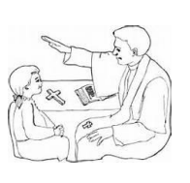• Gathering Hymn

• Greeting

• Opening Prayer

• Gospel

• Homily

• Examination of Conscience

• The Our Father

• Concluding Prayer

**• Individual Confession and Absolution:**

**➢ When the priests have reached the place of confession, the children will be led by their Catechist to a priest for individual confession.**

**➢ When each child has had their confession heard he/she will return to the pew to pray their penance.**

**➢ Once they are finished each child will remain in his/her pew until one parent comes to the pew to take him/her home. In order to foster the sacredness of this sacrament, we request that all parents refrain from all speaking and take no pictures during confessions. Any parent who wishes to go to confession is invited to do so after all the children have celebrated their First Penance. You will find an Examination in the pew for you.**

**In order to foster the sacredness of this sacrament, we request that all parents refrain from all speaking and take no pictures during confessions.**

**Any parent who wishes to go to confession is invited to do so after all the children have celebrated their First Penance. You will find an Examination in the pew for you.**

**PROCEDURE FOR THE RITE OF RECONCILIATION TO BE PRACTICED AT HOME**

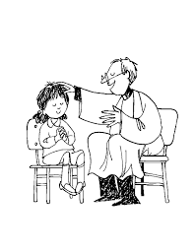The following is the procedure the children learn to follow as they prepare for their First Reconciliation. Large type/bold is actual statements the children will say during Reconciliation.

**PRIEST**: The priest greets the child.

**PRIEST**: In the name of the Father, and of the Son, and of the Holy Spirit. (Child makes the sign of the cross on themselves.)

**CHILD**: (child answers) Amen.

**CHILD**: Bless me Father for I have sinned. This is my first confession. These are my sins.

**PRIEST**: The Priest talks to the child about their sins, gives them their penance (some prayers or something to do) and asks the child to say the Act of Contrition.

**CHILD**: My God, I am sorry for my sins with all my heart. In choosing to do wrong and failing to do good, I have sinned against you whom I should love above all things. I firmly intend, with your help, to do penance, to sin no more, and to avoid whatever leads me to sin. Our Savior Jesus Christ suffered and died for us. In his name, my God, have mercy. Amen

**PRIEST**: The Priest says a prayer over the child and absolves them of their sins. The prayer will end with the Priest saying: “I absolve you of your sins in the name of the Father, and of the Son, and of the Holy Spirit.” (The child makes the sign of the cross on themselves.)

**CHILD**: (child answers) Amen

**PRIEST**: Go in Peace.

**CHILD**: Thank you, Father. (Child goes back to their pew, kneels and prays their penance silently or says a prayer of Thanksgiving. Part of the penance may be an action that they do to show they are really sorry.) Accept one another as Christ accepted you

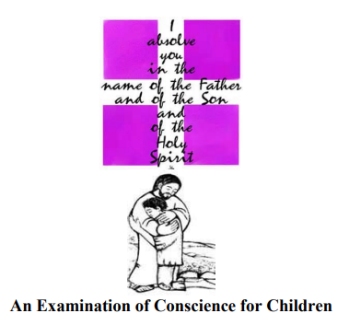

**An Examination of Conscience for Children- PREPARATION:** Take time before confession to think about how your behavior hurts Jesus because we hurt ourselves and/or others. This is your Examination of Conscience and every person ought to consider these things every day.

1. **I am the Lord, your God. You shall have no other gods beside me.** (Make God most important in your life.) Have I put God first, or have I sometimes made other things in my life more important than God? Do I remember to pray to God? Do I choose what God wants for me over what I want for myself?

**2. You shall not take the name of the Lord, your God, in vain. (Use God’s name the right way.)** Have I used God’s name with care? Have I used God’s name in the wrong way? For example: Saying “God” when I wasn’t really talking to him or talking about him.

**3. Remember to keep holy the Sabbath Day. (Make Sunday a day to worship God.)** Did I miss Mass on Sunday through my own fault? Have I tries my best to worship God at Mass by singing, praying and listening? Have I misbehaved during Mass?

**4. Honor your father and your mother. (Love your parents and follow their rules.)** Have I obeyed my parents - even when they are not looking? Have I talked back to them? Have I obeyed my teacher and other adults in charge of my care?

**5. You shall not kill. (Be kind to people and animals God made.)** Have I been kind to others? Have I solved disagreements in a peaceful way? Have I fought with anyone?

**6. You shall not commit adultery. (Be respectful in the things you do.)** Have I been respectful in my actions. Have I followed God’s rules in how I treat my body and respect the bodies of others?

**7. You shall not steal. (Take care of other people’s things; don’t take what belongs to others.)** Have I respected other people’s things? Have I taken something that does not belong to me? Have I cheated in my dealings with others?

**8. You shall not lie. (Tell the truth.)** Have I told the truth? Have I told a lie or things that were partly true?

**9. You shall not desire your neighbor’s wife. (Keep your thoughts and words virtuous.)** Have I been virtuous in the things I think and say? Have I watched any movies or shows that I should have not see? Have I tried to keep my mind on good things?

**10. You shall not desire your neighbor’s good. (Be happy with the things you have.)** Have I been happy with the things I have? Have I been jealous of others?



**Assumption of the Blessed Virgin Mary**

**Celebration of First Communion**

**May 3, 2025 11:00AM**

**Children Arrive 10:30AM**

**Before the day of Communion, your child’s banner will be displayed on the pew ends. This is a beautiful memento for you and your child as a remembrance of this very special day.**

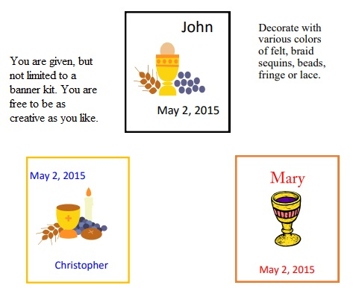

**COMMUNION ATTIRE**

## https://d6iyrqjd26xke.cloudfront.net/4002wf/full.jpghttps://d6iyrqjd26xke.cloudfront.net/00752elladress/full.jpgAs a sign of purity during the sacrament of First Communion, all the children will wear white. "First Holy Communion is the common name for a person's first reception of the sacrament of the Eucharist. Roman Catholics recognize the importance of this event as the Eucharist is the central focus of the sacramental life of the Catholic Church. With regards to First Holy Communion, the Catechism teaches us "Having become a child of God clothed with the wedding garment, the neophyte is admitted 'to the marriage supper of the Lamb' and receives the food of the new life, the body and blood of Christ." As a sign of purity, the garment is traditionally white.

**Invitation to Communion**

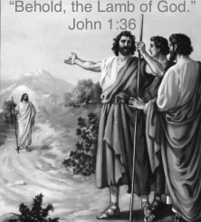

Priest: Behold the Lamb of God, who takes away the sins of the world

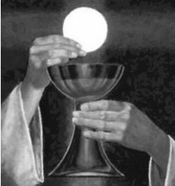

People: Lord, I am not worthy that you should enter under my roof, but only say the word and my soul shall be healed. Blessed are those called to the supper of the Lamb.

[invitation-to-Communion-1.pdf (stbart-stjoe.org)](https://stbart-stjoe.org/wp-content/uploads/2020/06/invitation-to-Communion-1.pdf)

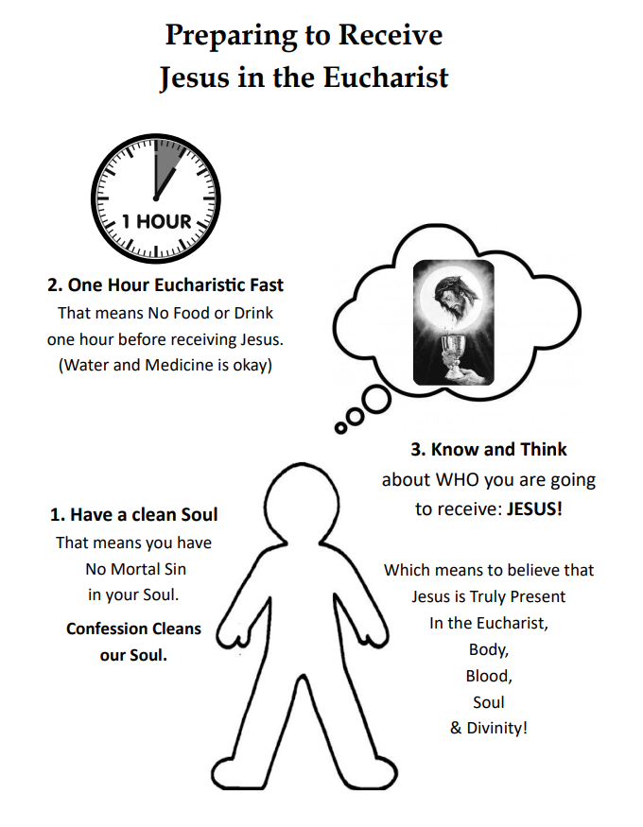

**We Pray Together** Praying together is powerful. Lives are changed and our families become bonded to one another and stronger in family faith. Pray together as a family. Talk about all these holy acts as one. In Godspeed, you will see miracles before your own eyes.

1.My child knows these prayers very well and has good understanding of them.

___Our Father ____Glory be ___Hail Mary ___Act of Contrition ___Guardian Angel Prayer ___Grace

2. My child knows there are three persons in One God, and can name each person.

(The Father, The Son and The Holy Spirit)

3. My child can explain Grace.

(God’s life in our souls. We need Grace to enter heaven)

4. My child can explain what a sacrament is and give an example of one.

(A Sacrament is an outward sign given to us by Jesus to give grace. Baptism, Eucharist, Reconciliation, Confirmation, Holy Orders, Matrimony, Anointing of the sick)

5. My child has a desire to receive Jesus in The Eucharist, and is developing a relationship with Jesus through parental role modeling, prayer and Mass attendance.

6. My child knows that Jesus gave us The Eucharist at the Last Supper. (Mark 14:12-26)

7. My child knows and believes that The Eucharist is Jesus, His Body, Blood, Soul and Divinity, and is hidden under the appearance of bread and wine. This is a miracle!

(Parent note: Catholic’s believe in Transubstantiation, which means the substance of the bread and wine are truly Jesus only leaving the appearance of bread and wine. John 6:30-58)

8. My child knows that Jesus gave priests the power to change bread and wine into The Body and Blood of Jesus. Priests do this when they offer The Sacrifice of The Mass and say the words of Consecration: “This is My Body” and “This is My Blood”.

(Parent note: A sacrifice is a gift to God which tells Him we love Him. The Mass is the sacrifice in which Christ, through the priest, offers Himself to The Father and we offer ourselves with Him.)

9. My child has a familiarity with the movements, prayers, gestures of the Mass. Especially the response to the Invitation to Communion: “Lord I am not worthy that you should enter under my roof, but only say the word and my soul shall be healed.”

10. My child knows how to prepare to receive Jesus worthily?

1. One hour Eucharistic Fast.

2. No mortal sin. (been to confession recently)

3. Knows Jesus is truly present in the Eucharist.

11. My child knows how to receive The Eucharist Reverently.

1. Bow before stepping close to the priest.

2. Saying “Amen” when the priest says “The Body (or Blood) of Christ.”

3. Offering cupped hands and then taking the bottom hand take The Eucharist and place in their mouth before moving away from the priest. Or offer an open mouth with tongue extended and chin up. (Parent can practice with a cracker at home.)

12. My child knows to make an Act of Thanksgiving after receiving Holy Communion. They should kneel in their pew after Communion to offer prayers of Thanksgiving and asking for blessings for themselves and others. This is the time they will be the closest to Jesus!

**Prayers for 1st Communicants Made Powerful When Prayed as a Family**

**ACT OF CONTRITION**

My God, I am sorry for my sins with all my heart. In choosing to do wrong and failing to do good, I have sinned against you whom I should love above all things. I firmly intend, with your help, to do penance, to sin no more, and to avoid whatever leads me to sin. Our Savior Jesus Christ suffered and died for us. In his name, my God, have mercy.

**LORD’S PRAYER**

Our Father, who art in heaven, hallowed be thy name. Thy kingdom come, thy will be done, on earth, as it is in heaven. Give us this day, our daily bread and forgive us our trespasses as we forgive those who trespassed against us. Lead us not into temptation, but deliver us from evil. Amen

**HAIL MARY**

Hail Mary, full of grace, the Lord is with you. Blessed are you among women and blessed is the fruit of your womb, Jesus. Holy Mary, Mother of God, pray for us sinners, now, and at the hour of our death. Amen

**GLORY BE**

Glory be to the Father, and to the Son, and to the Holy Spirit. As it was in the beginning, is now, and ever shall be world without end. Amen

**PRAYER OF THANKS AFTER COMMUNION**

I thank You, O Lord my God, for You have made me worthy to be a partaker of Your Holy Things. I thank You, for You have permitted me, the unworthy, to receive your Son.

**GRACE BEFORE MEALS**

Bless us, O Lord! and these Thy gifts, which we are about to receive from Thy bounty, through Christ our Lord. Amen.

**ANGEL of GOD**

Angel of God, my guardian dear, to whom God’s love entrusts me here. Ever this day be at my side, to light and guard, to rule and guide. Amen.

**1st Communicant Knowledge to be Reviewed at Home**

**Mortal Sin/Serious Sin:** -a serious offense against God -destroys the virtue of charity within us -involves serious immoral acts, or grave matter such as the Ten Commandments -can cause eternal separation from God -requires full knowledge and complete consent

**Venial Sin:** -less serious because they do not destroy our relationship with God -wrong acts committed without full knowledge of just how wrong they are.

**Social Sin**: -collective effect of sin over time, which corrupts society and its institutions by creating “structures of sin” -racism, sexism and institutionalized poverty are examples Capital Sins (Seven Deadly Sins) -lead to and reinforce all sorts of other sinful actions, thoughts and omissions -increase the tendency to sin and cause us to turn away more and more from God

**While children need not recite the following they are to be familiar with the concepts:**

**Pride**: believing you are better than others, disrespecting others -Greed: hoarding money or things

**Envy**: resentment we direct to others who have success, things, privilege

**Wrath**: strong anger to seek revenge and prevents reconciliation

**Lust**: undisciplined, unchecked desire

**Gluttony**: excessive eating or drinking

**Sloth**: habitual laziness, failing to put forth effort and take action

**Ten Commandments**

1. I am the Lord your God; you shall not have strange Gods before me.

2. You shall not take the name of the Lord your God in vain.

3. Remember to keep holy the Lord’s Day.

4. Honor your father and your mother.

5. You shall not kill.

6. You shall not commit adultery.

7. You shall not steal.

8. You shall not bear false witness against your neighbor.

9. You shall not covet your neighbor’s wife.

10. You shall not covet your neighbor’s goods.

**Communion II Calendar 2024-2025**

**Wednesdays:** 4:15-5:30PM

Rose Strohmaier, Parish Catechetical Leader—908-303-9692

**DROP OFF AND PICK UP—PARENTS MUST PARK CARS IN THE KNIGHTS’ PARKING LOT AND COME INTO THE CAFETERIA TO PICK UP CHILDREN**

**September**

Wednesday 18—**6:00PM Meet with Mrs. Rose in auditorium**

**Sunday** 22**—Faith Formation Family Mass-10:00 AM ALL FAMILIES MUST ATTEND**

Wednesday 25—Faith Formation

**October—Mrs. Leguizamon—Please prepare Children for Class Mass**

Wednesday 9—Faith Formation--**Father Leo-- Parent Session**

**Sunday 13—Communion II Class Mass—10:00 AM Arrive by 9:45**

Wednesday 16—Faith Formation

Wednesday 23—Faith Formation— **Empowering God’s Children Video**

**Monday 28—Norma Rothshadl from OSV—Training—Catechists Only-No Children**

Wednesday 30—Faith Formation—Holyween During Class—Parents Invited

**November**

**Friday 1—All Saints Day—Holy Day—All Attend Mass**

Wednesday6—Faith Formation--**Father Leo-- Parent Session**

Wednesday 13—Faith Formation—**Adoration**

**Sunday** **17—Communion II Class** Mass—10:00 AM Arrive by 9:45

Wednesday 20—Faith Formation

Wednesday27— **No Faith Formation Happy Thanksgiving!**

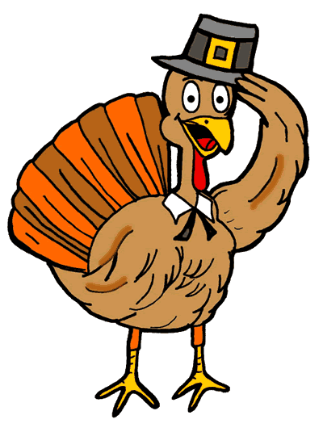

This Photo by Unknown Author is licensed under CC BY-NC-ND

**December**

Wednesday 4—Faith Formation

Wednesday 11—Faith Formation

Wednesday 18—Faith Formation **– After Class at 6:00PM Tree Blessing -- Hot Chocolate and Cookies**

Saturday 21—**4:15—Children’s Mass and Nativity (Nativity will take place before 5:30PM Mass)**

**Wednesday 25—Merry Christmas, Holy Day—All go to Mass**

**January**

**Wednesday 1—Mary, Mother of God—Holy Day, All Attend Mass**

Wednesday 8—**No Faith Formation for Children-Catechist Night of Reflection**

Wednesday 15—Faith Formation

**Sunday** **19—Communion II Class Mass**—10:00 AM Arrive by 9:45

Wednesday 22—Faith Formation--**Father Leo-- Parent Session**

Wednesday 29—Faith Formation- **Evaluations go Home—Adoration**

**February**

Wednesday 5—Faith Formation

Wednesday 12—Faith Formation

Wednesday 19— Faith Formation—**Father Leo-- Parent Session**

**Saturday 22—1st Reconciliation Penance Service—10:00am**

Wednesday 26—Faith Formation

**March**

Wednesday 5— **Ash Wednesday** – No Faith Formation

Wednesday 12—Faith Formation **Empowering God’s Children Video**

**Sunday** 16— **Communion II Class Mass**—10:00 AM Arrive by 9:45

Wednesday 19—Faith Formation for Children—**Parent Meeting with Father Leo about Communion**

Wednesday 26—Faith Formation

**April**

Wednesday 2—**No Faith Formation for Children-Catechist Night of Reflection**

**Saturday 5—Communion Retreat with Parents 10:00AM-12:00 Noon**

Wednesday 9—Faith Formation—**Reconciliation—Parents encouraged to receive**

**Sunday 13—Palm Sunday**

Wednesday 16—Faith Formation

**Sunday 20—Easter**

**Wednesday 23—Easter Vacation**

Wednesday 30—Faith Formation for all with practice for Communion during Session--Evaluations go home

**May**

**Saturday 3—1st Communion—11:00AM Children arrive at 10:30AM**

**Sunday 4—Family Mass with May Crowning–All Families Must Attend**

Wednesday 7—Faith Formation