

Mrs. Ferise

Communion I

2023-2024

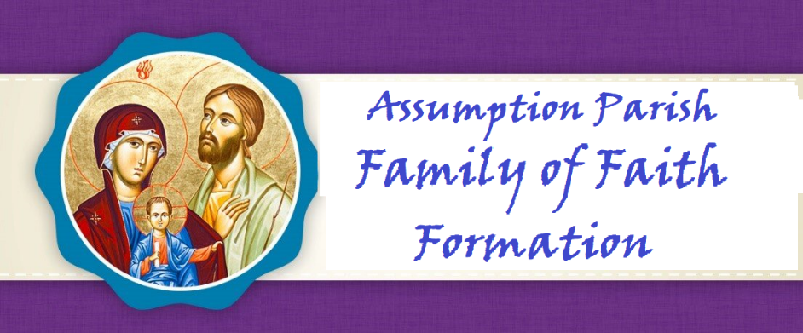

**Dear Parents,**

*Along with our staff and Catechists, I want to welcome you to a new year as we journey together on the path to Heaven. I am grateful for the opportunity to walk this walk with you as your Father in faith.*

*The schedule of classes, events, meetings, trips, and spiritual gatherings are created all with the desire to offer you and your children many opportunities to deepen your love for Jesus. Loving Jesus is central to our faith. Nothing we teach or say will make sense to anyone without the foundation of love for Christ to come first. It is our hope that your entire family will take full advantage of these opportunities.*

*You are a gift to me, and I pray you are as joyful and excited as I am, with the start of our new year of formation. My gift to you is my prayer that God may bless you and your children. May He lead you to grow and deepen your faith as your family participates in all we offer you in His glorious and holy name.*

**Fr. Leo, Pastor**

**Dear Parents,**

*Welcome to the Church of the Assumption for the Blessed Virgin Mary Parish Faith Formation Program. It is our privilege to support you in your efforts to guide your child to a deeper and more meaningful Christian life following the doctrines and teachings of the Catholic Church. We are here to help all families of Assumption Parish with their faith formation needs and desire to engage the entire family on their spiritual journey. Please let us know what we can do to serve you.*

**Rose Strohmaier**

**Parish Catechetical Leader**

## PARISH MISSION STATEMENT

The Mission of the Catholic Community of The Church of the Assumption is to be led by the Word of God, to proclaim God in our words and actions, and to bring all people to God like Mary our Blessed Mother.

**VISION OF OUR FAITH FORMATION PROGRAM**

The mission of the Office of Faith Formation is to proclaim the message of Jesus, to teach His truth, and to extend His love to all people. We hope to enable our parish community, beginning at birth and continuing through life, to discover, grow and mature in their faith experience, to deepen their relationship with Christ and His church, and to realize an excitement about the wonderful gifts received by participating in our faith.

**ROLE of the Parents**

**Family Participation**

Jesus is truly present with us at every Mass and that is why the significance of family Mass attendance cannot be minimized and is at the heart of our faith. It is our moment of intimacy with our Lord. This is His gift of love for us so we may grow in love for Him. Absolutely nothing about faith makes sense without loving Christ first. ***Faith Formation families are to attend either Saturday night or Sunday morning Mass.******Four times during the Faith Formation year, Father Leo meets with parents to discuss an article on the teaching of the faith which fulfills Diocesan guidelines which state:***

*“Parents need to understand that formal faith formation is a continuous developmental process that begins with First Communion preparation and continues through Confirmation. Attendance at parent formation sessions is required to help parents fully participate in their child’s preparation.”*

Pray the prayers in this handbook together with your child so the entire Family grows in faith as one. Your child will learn these prayers before entering Communion II.

**Reconciliation Preparation Begins at Home**

• Look for and encourage opportunities to use the phrases, “I love you,” “I am sorry,” and “I forgive you” with each other.

• Make a habit of making peace with each other before going to bed.

* Bless your child with the sign of the cross you say “good night”.

• Attend a parish reconciliation service as a family, especially during Advent or Lent.

• Use opportunities that are part of everyday family life to talk with young children about the difference between mistakes and sin.

**First Communion Home Activities**

• Nurture your child’s understanding of God’s love for them and their response of thanksgiving.

• Nurture your child’s relationship to Jesus Christ in prayer and worship.

• Enhance your child’s appreciation and active participation in the Mass

• Develop your child’s/family’s sense of belonging to a community of disciples who love as Jesus’ love.

**We Pray Together**

**Praying together is powerful. Lives are changed and our families become bonded to one another and stronger in family faith. Pray together as a family. Talk about all these holy acts as one. In Godspeed, you will see miracles before your own eyes.**

1. My child knows these prayers very well and has good understanding of them.

___Our Father ____Glory be ___Hail Mary

___Guardian Angel Prayer ___Grace Before Mea

1. My child can make the sign of the cross and knows there are three persons in One God. *The Father, The Son, and The Holy Spirit*
2. My child knows that we receive Grace from God.
3. My child can explain that Original sin is removed during Baptism.
4. My child is developing a relationship with Jesus through prayer, Mass attendance and parental role modeling.
5. My child knows that Jesus gave us The Eucharist.

7. My child knows and believes that The Eucharist is an important sacrament so we can get to Heaven.

8. My child prays for others.

9. My child knows the names of the Holy Family. *Jesus, Mary, and Joseph*

10. My child knows the name of our pastor.

**Invitation to Communion**

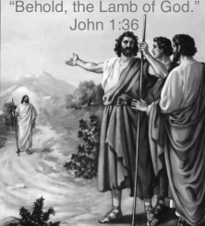

Priest: Behold the Lamb of God, who takes away the sins of the world

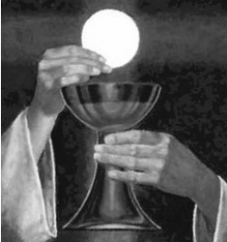

People: Lord, I am not worthy that you should enter under my roof, but only say the word and my soul shall be healed. Blessed are those called to the supper of the Lamb.

[invitation-to-Communion-1.pdf (stbart-stjoe.org)](https://stbart-stjoe.org/wp-content/uploads/2020/06/invitation-to-Communion-1.pdf)

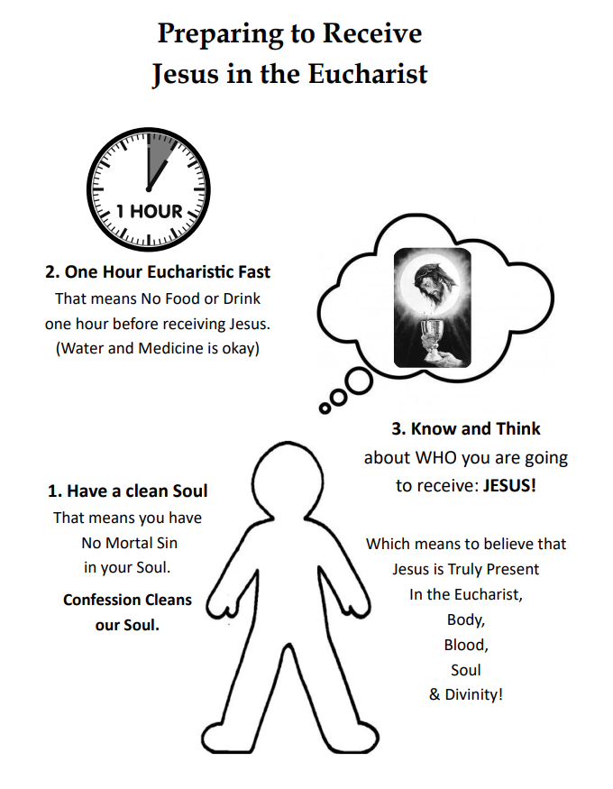

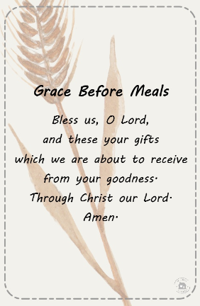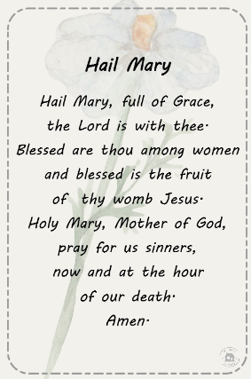

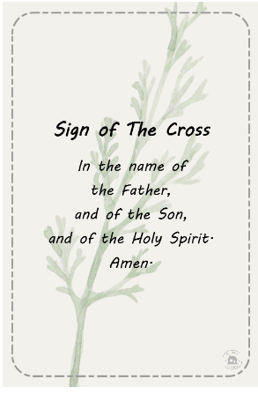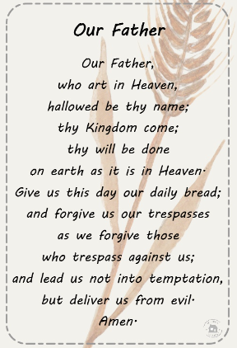

**Communion I Faith Formation Calendar 2023-2024**

**September**

Wednesday 13—Faith Formation 4:15PM & 6:30PM—Parents and children meet in the cafeteria

both 4:15 and 6:30 sessions

***Sunday*** 17***—Faith Formation Family Mass-10:00 AM***

Wednesday 20—Faith Formation

Wednesday 27—Faith Formation

***Father Leo-- Parent Session discussing an article on the teaching of the faith***

**October**

Wednesday 4—Faith Formation

Wednesday 11—Faith Formation

Wednesday 18—Faith Formation

**Sunday** 22—***Communicants Rite of Enrollment with Families—10AM—***

***Please arrive at 9:45 and sit in the main church.***

***Children will sit with their families***

Wednesday 25— Faith Formation

***Father Leo Parent Session discussing an article on the teaching of the faith***

**November**

Wednesday **1—No Faith Formation All Saint’s Day –**

**Holy Day – All go to Mass—See you there! 8:00AM, Noon, 6PM and 7PM Spanish**

Wednesday 8—Faith Formation Faith Formation **Adoration 5:00-5:10-Commuinion I& II**

Wednesday 15—Faith Formation

Wednesday22***—No Faith Formation Happy Thanksgiving!***

Wednesday 29—Faith Formation

**December**

Wednesday 6

**Friday 8—Feast of the Immaculate Conception—Holy Day—All go to Mass**

Wednesday 13—Faith Formation

Wednesday 20—Faith Formation

****Saturday 23—**4:15—Children’s Mass and Nativity (Nativity will take place before 5:30PM Mass)**

**Monday** 25—Christmas –All go to Mass

**January**

**Sunday 1—Mary Mother of God-Holy Day—Attend Mass**

Wednesday3—**NO FAITH FORMATION**—Catechist Night of Reflection

Wednesday 10—Faith Formation

Wednesday 17—Faith Formation

***Father Leo-- Parent Session discussing an article on the teaching of the faith***

Wednesday 24—Faith Formation-Faith Formation **Adoration 5:00-5:10-Commuinion I& II**

***Evaluations Sent Home***

Wednesday 31—Faith Formation

**February**

Wednesday 7—Faith Formation

Wednesday 14—**Ash Wednesday** – No Faith Formation

Wednesday 21—Faith Formation

Wednesday 28—Faith Formation

**March**

Wednesday 6—Faith

Wednesday 13—Faith Formation

Wednesday 20—**Catechist Training-No Children**

Wednesday 27—Faith Formation

***Father Leo Parent Session discussing an article on the teaching of the faith***

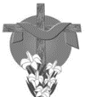**Sunday** 31— ***Happy Easter!***

**April**

Wednesday 3—**Easter Vacation**

Wednesday 10— Faith Formation

Wednesday 17—Faith Formation

Wednesday 24—Faith Formation

***May***

Wednesday 1—Faith Formation—Last evaluations go home

**Sunday** 5—**May Crowning and Closing Mass** -10:00AM Mass

Wednesday 8—Tentative Last Session Faith Formation

++To limit the use of bathrooms, it is important that all children use the restroom before their designated session. We meet for only 1.25-1.5 hours which helps to limit the necessity to use the restrooms.

++Children will go directly to their classroom upon arrival.

**DROP OFF AND PICK UP—PARENTS MUST PARK CARS IN THE KNIGHTS’ PARKING LOT AND COME INTO THE CAFETERIA TO PICK UP CHILDREN.**

**Your kind attention to this matter is greatly appreciated. Every hild’s safety is important to us.**